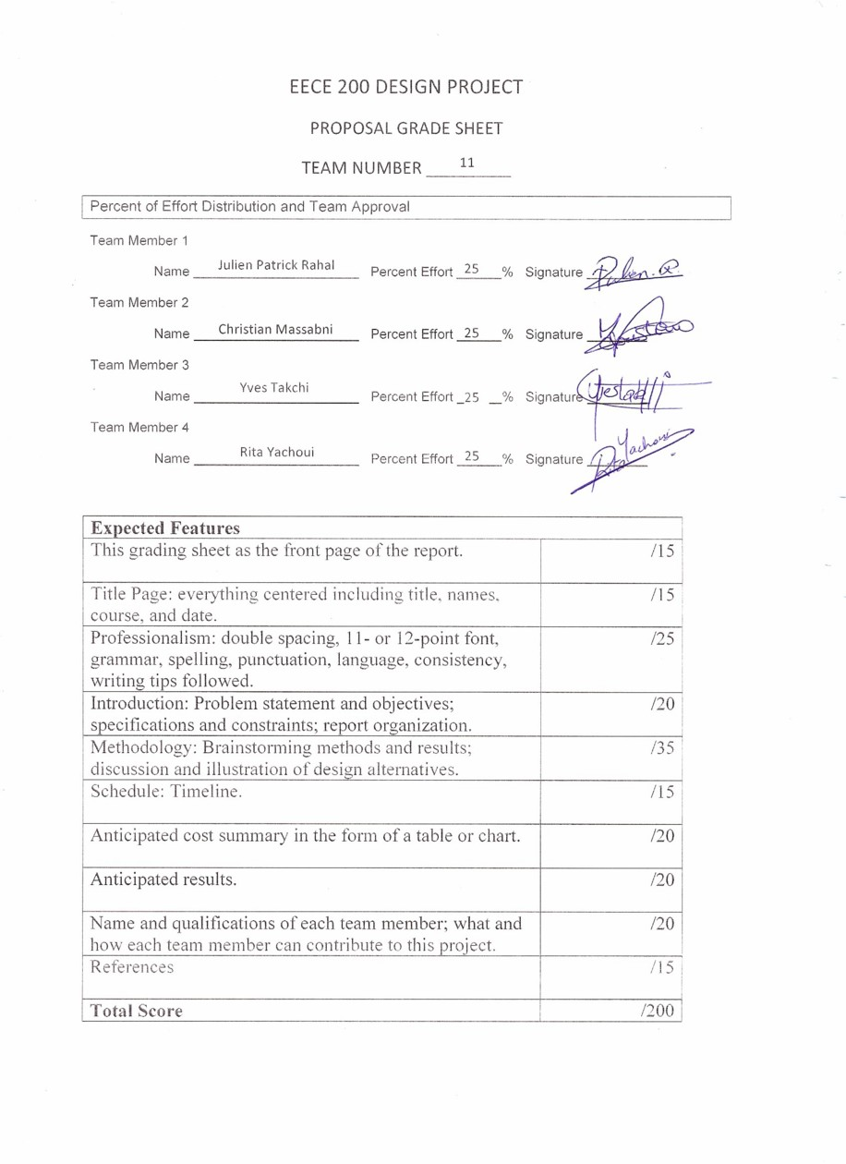

Project Proposal

ELEVATOR MODEL

Team number: 11

The group members are:

Yves Takchi 201200948

Christian Massabni 201200642

Rita Yachoui 201203800

Julien Rahal 201203217

Introduction
- Project Purpose:
This project contributes to a big part of our final grades in EECE 200. Therefore, for us to pass this course, it is necessary to complete this project.
- Problem Statement:
In this project, we are going to build and program a 3-floor model elevator. The programming and control interface will be developed using National Instruments Labview software. The program will be downloaded to a NI Speedy 33 DSP board that will run on standalone mode.
- Project Objectives
While building a LABview VI designed to operate an elevator we will :
  - Enhance our LABview programming skills and apply them to a practical application.
  - Understand the problem solving process.
  - Learn how to design and develop an engineering projects
  - Develop our ability to work in a team of engineers

- Project Specifications :
- Digital Inputs :
    - Three photo resistors fixed on each floor, to receive light from a light bulb fixed below the elevator cabin.
    - Three digital switches on each of the floors to allow the user to call the elevator
    - A fourth photo resistor inside the cabin near the door entrance that is constantly hit by an infrared or laser light. If something obstructs the light, the sensor indicates it.
    - A digital input for a temperature sensor installed to the cabin
  - Analog input
    - The built in microphones on the speedy 33 board. Three specific tones are assigned to each level which will allow the program to determine what itinerary to take.
  - Digital Output :
    - Two digital outputs to a seven segment display on the first floor used to display the position of the elevator
    - Three digital outputs that control the motors that opens/closes the doors of each floors.
    - One digital output controlling the pulling motor's direction.
    - One digital output that controls a dc fan installed in the elevator.

- Project constraints :
    - The use of the speedy 33 board is mandatory.
    - LAB view graphical programming language is required.
    - The group team members are limited to 4.
    - The project is subject to a time limit.

- Organization Page
  - Grading Sheet 1
  - Title Page 2
  - Introduction: 3
    - Project Purpose 3
    - Problem Statement 3
    - Project Objectives 3
    - Project Specification 4
    - Project Constraints 5
  - Methodology:
    - Brainstorming methods and results 7-8-9
    - Design alternatives:
      - first design with illustration 10-11-12
      - first alternative 13
      - second alternative 13
      - efficiency discussion 13-14
  - Time schedule 14
  - Cost estimation 15
  - Anticipated results 16
  - Team member qualifications 17
  - References 18

- Methodology:
  - Brainstorming Methods and Results:
This project being very challenging, brainstorming was essential to our
design. Our brainstorming results are:
    - The material used should be light and resistant. The door material should be transparent in order to show the cabin content and design.
    - Each door should be resting on gears which are connected to a motor in order to ensure a smooth movement.
    - Single tones should be used to control the cabin movement to reduce noise interactions.
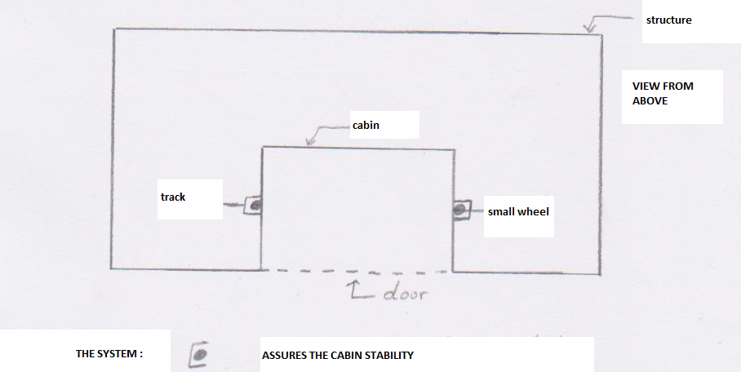
    - The cabin should move on tracks to lower the chances of vibrations and friction.

    - The level sensors should be continuous and not discrete (this will be explained in the efficiency discussion).
    - The pulling motor should be placed on the highest part of the shaft and pull a counter weight.
    - The single seven segment display should be placed on the first floor.
    - The door obstruction sensor should be placed inside the cabin in order to minimize sensor quantity.
    - A door should be placed on every floor.
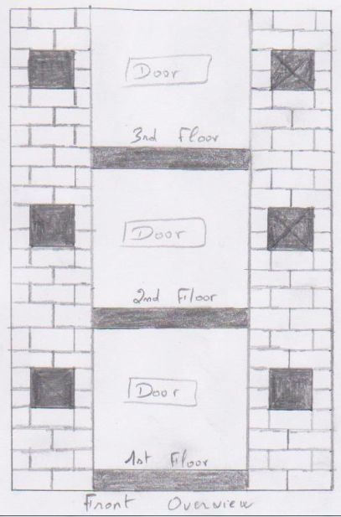
    - A temperature sensor records the temperature. If the temperature exceeds a certain threshold, the cabin goes into a safe mode. The lighting changes and a dc fan are activated.
    - The speedy should work on stand-alone mode.
    - All wirings should be hidden inside the shaft.

  - First design:
    - The material for the shaft and skeleton and cabin is aluminum composite material (aluminum-PVC) and the doors are made out of Plexiglas.
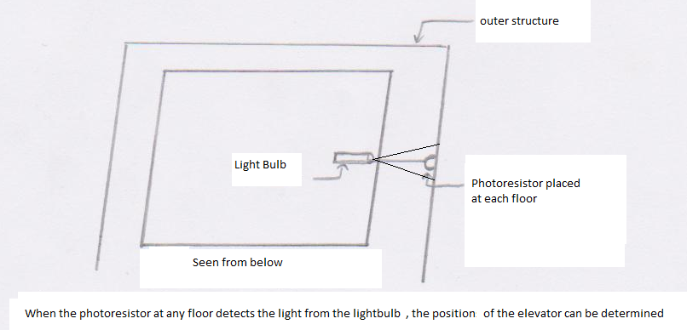
    - Level sensors: Three photo resistors are installed on each floor on the inside of the shaft, and one large radius light bulb is fixed below the elevator cabin. When the cabin reaches a level, the light from the light bulb hits the photo resistor and the sensor circuit is closed, indicating the presence of the cabin on that floor. When no light hits the sensor the circuit is opened.

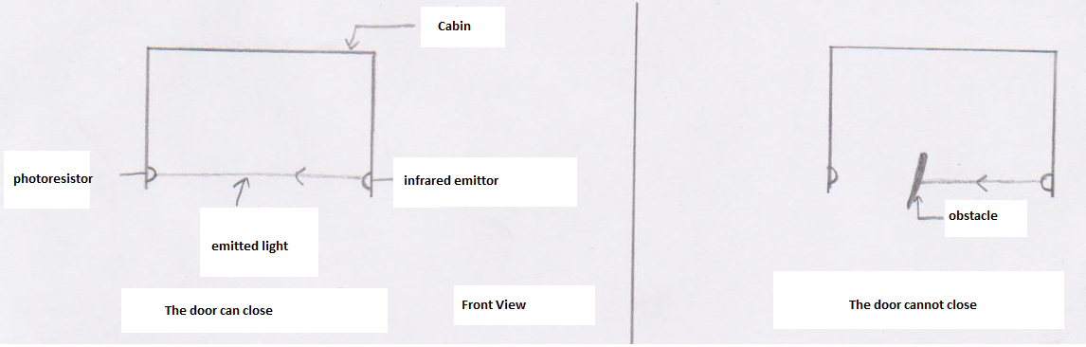
    - Door sensors: a single photo resistor is placed in the inside threshold of the cabin with an infrared source constantly hitting it. When something obstructs the infrared beam, no light hits the photo resistor and the circuit is open, preventing the door from closing.

    - A motor with gears attached to the door on each level , a command opens half of it with one rotational motion( clockwise) and closes with a second command that turns it in the opposite rotational motion ( counter clockwise).

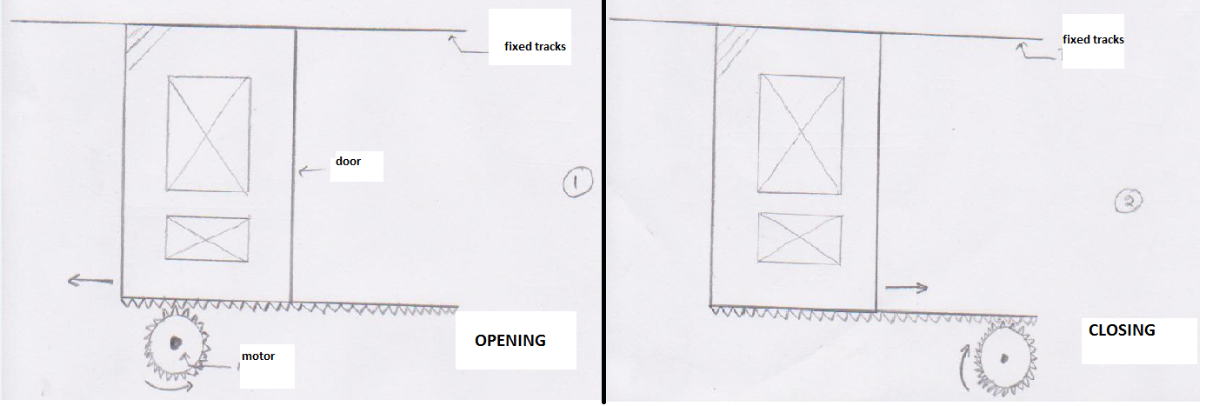

    - A motor on the top of the shaft pulls and drops a counterweight connected to the cabin. When the motor isn’t running, the weight of the counterweight prevents the cabin from sliding.
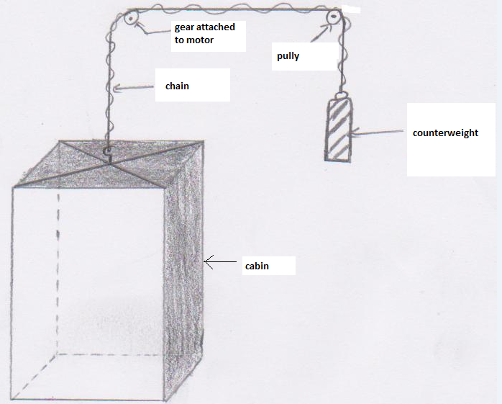
    - A temperature sensor inside the cabin gives real time data collection to the speedy board. If the temperature exceeds the threshold, a dc fan on the top of the cabin is activated and the lighting changes to a single red LED.
    - Push buttons are fixed on every level to allow the user to call the elevator from a floor
  - First Alternative
    - Level Sensors : 3 motion detectors fixed on every level detect the passing of the elevator
    - Door sensor : a laser emitting diode hits the photo resistor instead of the infrared emitter
    - Switches are used instead of the push buttons to call the elevator
  - Second Alternative
    - Level Sensors: A metal plate is placed underneath the cabin with a piece sticking out, and on each floor an open circuit that close when the metal piece of the elevator comes in contact with it, indicating the presence of the elevator on that floor.
    - Door sensor: a motion detector detects if someone is moving near the door entrance.
  - Efficiency discussion:
    - Level sensors: the light bulb/photo resistor solution seems the most efficient .The motion sensor solution offers an easy fix but the collected data is discrete , it only shows that the elevator has passed a point ,when it is idle it cannot determine the cabin’s position. The metal plate solution offers too many failing scenarios (the plate doesn’t hit the circuit as it should, the plate gets damaged…)
    - Door sensors: the motion sensor is easy to procure but again offers only discrete data collection. Between the infrared/laser solutions, the infrared is more efficient but the laser emitter is easier to procure.
    - Switches: both solutions are equally efficient but push buttons are more harmonious with the elevator design.
- Time Schedule :

Dates & Deadlines | Work due or done
Wednesday 16th Nov 2011 | Group Formation (Naming) & Planning For Meetings
Saturday 19th Nov 2011 | Brain Storming & Research
Friday 25th Nov 2011 | Exchange Of Ideas & Work On Proposal
Monday 28th Nov 2011 | Proposal Report
Friday 16th Dec 2011 | Project Soft Demonstration
Wednesday 11th Jan 2012 | Project Deadline Software And Hardware
Thursday 12th & Friday 13th Jan 2012 | Project Presentation And Demo
Friday 28th Jan 2012 | Project Final Report & Log Book

*Extra meetings after the 28th of November will be scheduled later.

- Anticipated Cost Summary:

Article |  | Quantity |  | Unit price |  | Total Price
 |  | Board and motors
Speedy 33 |  | 1 |  | $600 |  | $600
Big pulling motor |  | 1 |  | $10 |  | $10
Motors for the doors |  | 3 |  | $5 |  | $15
 |  | Sensors
Temperature sensor |  | 1 |  | $2 |  | $2
Photo resistors  Lasers |  | 4  4 |  | $2  $5 |  | $8  $20
 |  | Others
LED Lights |  | 6 |  | $1 |  | $6
Cabin + shaft (Aluminum)  Wheels  Pulley + Tracks + Gears  Wiring |  | 1  5 |  | $22  $2 |  | $22  $10  $16  $5
Estimated Total Amount |  |  |  |  |  | $714

- Anticipated Results:

As a final result, we expect the elevator to function properly and according to plan. Our elevator should go up and down three floors without any unnecessary vibrations and while supplying full safety for its passengers. The elevator will respond to the calls on the different floors and will attend the different calls from the floors in the order or sequence that will be saved. The elevator will stop at every floor for 7 seconds if the cabin is clear. The elevator doors will not open except when the elevator reaches the specific floor. The motors and their direction should be arranged in a way to prevent the stopping of elevator cabin between the floors; the elevator should only stop when reaching the specific floors. The dc fan will be working according to the temperature sensor. As we will show during the project presentation, the hair dryer that initializes the change in temperature will be identified by the temperature sensor. Therefore the dc fan will be turned on or off according to the indication of the temperature sensor where the dc fan will be activated whenever the temperature exceeds some threshold temperature (which will be in degrees Celsius). Additional features will be included like the lightning, braking system and other audio effects. As for the sensors, their function is to stop the closing of the door when someone enters the elevator.

- Qualifications:
Each member of our group has participated effectively in this project. Each of us had a different function depending on his or her own skills and knowledge. The work on the project was divided in the following way according to each member:
Name | Qualifications | Allocated part of the project
Julien Rahal | Great organizational and cooperative skills. Clear understanding of the procedure and project material. Also has a skill in illustrating and drawing sketches. | Assures the complete interaction between the group members. Drew the designs clearly after they have been presented as essential ideas.
Yves Takchi | Deep understanding of the material and know-how of the project realization procedure, and mastery of the English writing language. | Presenting the basic ideas about the project and knowledge about where to find each material needed. Did the initial. Participated in editing the final draft of the proposal.
Christian Massabni | Very good leadership and organizational skills. Time management skills. Basic understanding of all the information presented during group discussions. | Organization of the group work and control over all the work done. Time management for the group. Participated in editing the final draft of the proposal.
Rita Yachoui | Good mastery of the English Language. Responsible for typing the proposal report. Offering creative ideas and additional aspects and components for the project. | Doing research on the subject. Participation in the group discussions as well as offering ideas.

- The four members have attended every group meeting and there was full cooperation and agreement.

- References:

    - Boujikian Electronics, Dora, Beirut-Tripoli Highway.
    - Proximity, Kaslik, Espace 2000 Building, ground floor.

